1) Natural Join: Cross product + common attributes equality condition

In natural join equality on common attributes hold and duplicate attributes are removed by default.

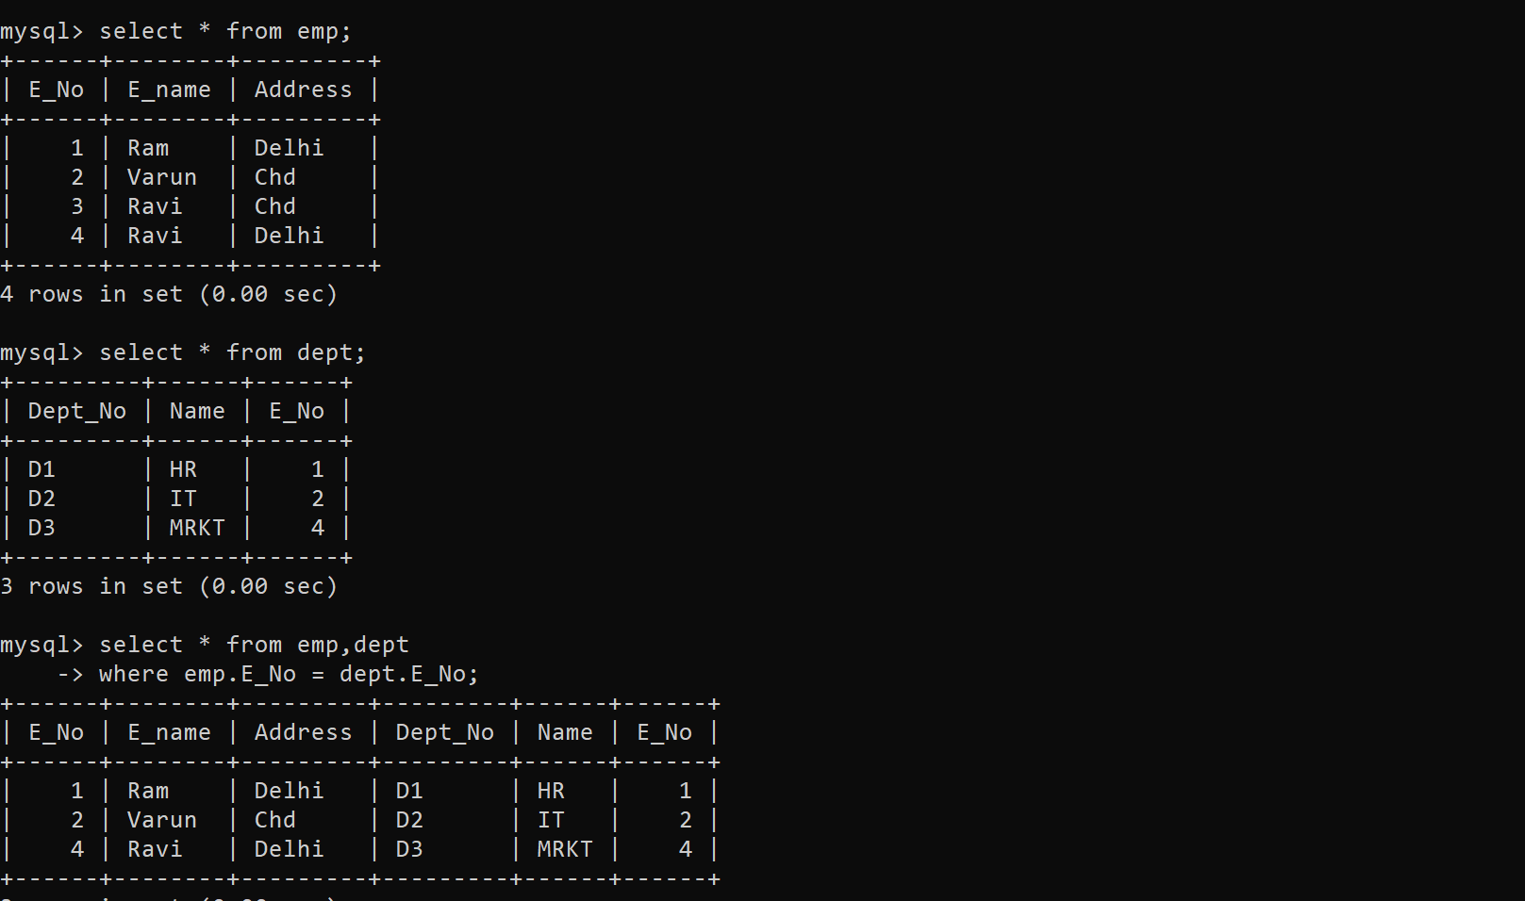

2) Self Join: Cross product of table with itself + common attribute condition

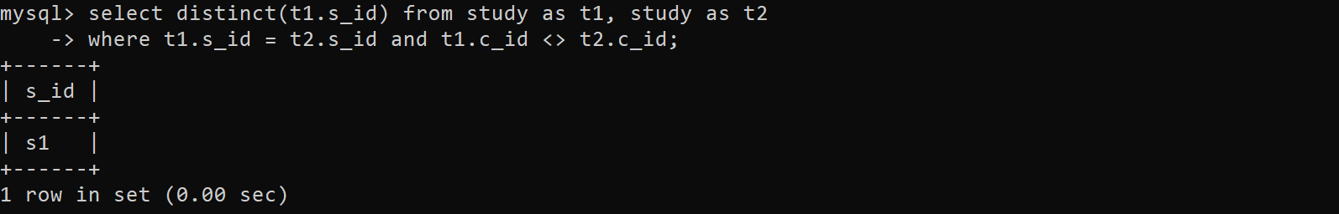

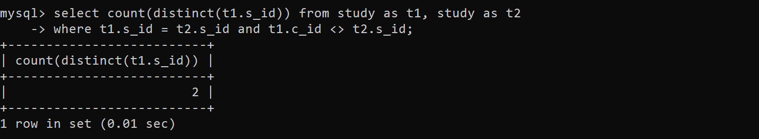

3) conditional Join: conditional join same as natural join but it contains at least one condition with minimum requirements that both tables contain’ s common attributes.

Cross product + common attribute + another condition

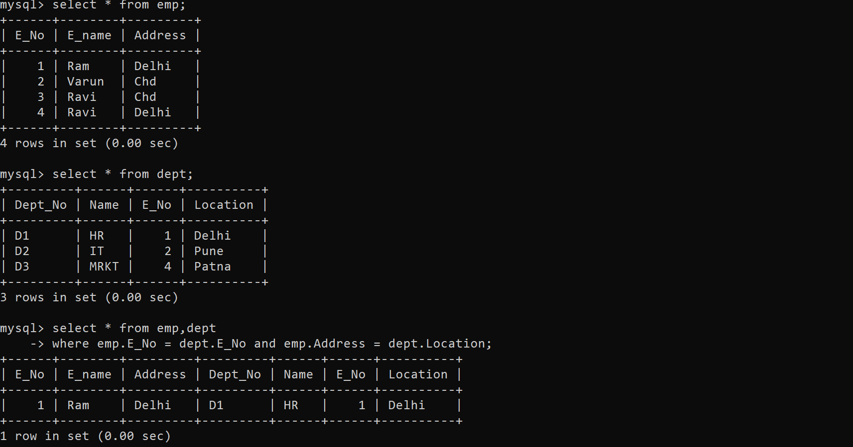

4) Left outer join: Give result on the basis of matching rows/tuples [same as natural Join]

The tuples that exists in left table but not in right table [Or doesn’t satisfy join condition will valued as null for attributes of r2]

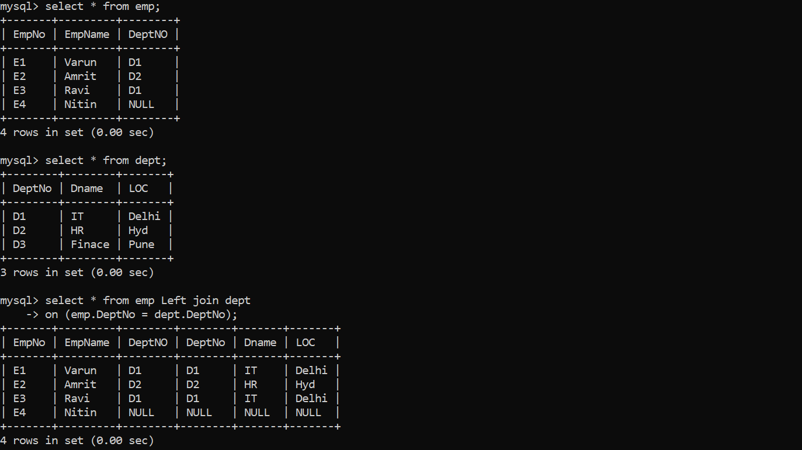

5) Right Join: right join give all the rows of r2 in result table. The tuples of r2 which doesn’t satisfy the join condition will have valued as NULL for the attributes of r1.

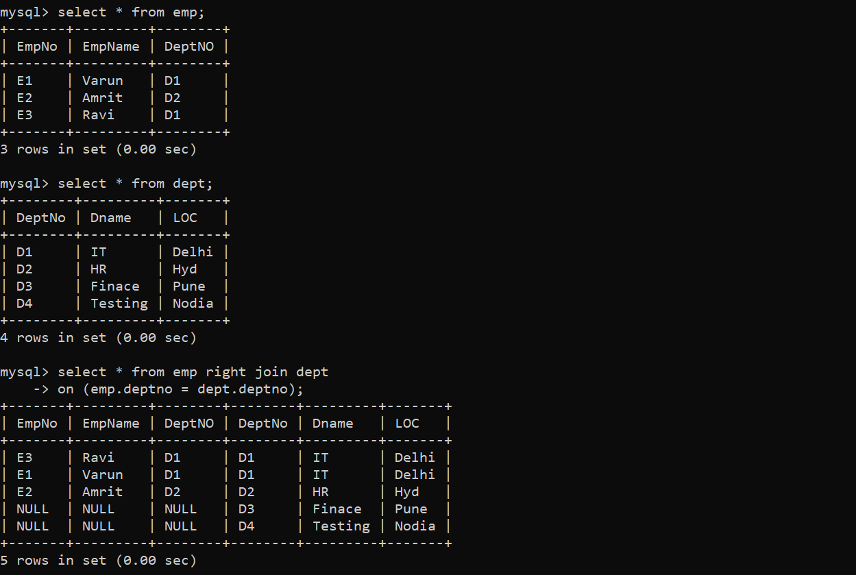

6) Full Join: on applying join condition on two relation r1 and r2, some tuples of r1 or r2 do not appear in result table which doesn’t satisfy the join condition.

But full outer join gives all the tuples of r1 as well as r2 in result table.

The tuples of r2 that doesn’t satisfy the join condition will valued as null for attributes of r1 and vice-versa.

